

January 17, 2023

Dear Sir or Madam:

I am writing this letter to describe the service of Supraja Gurajala to the Faculty Senate of the State University of New York at Potsdam.

Dr. Gurajala has been a very strong contributor to the work of the Faculty Senate. She has served three two years terms on standing committees Academic Programs and Curriculum Committee, Business Affairs Committee and Student Affairs Committee. Most faculty would serve only one term in the same time period. Even more significantly, Supraja served as the chair of the Student Affairs committee for one year. By virtue of that position, Dr. Gurajala also served on the Faculty Senate Executive Committee for one year.

Serving on Faculty Senate Committees is a significant contribution of service to the college. Shared governance is essential to the proper function of our college, and the large majority of Faculty Senate work is done in committees. All committees are required to meet monthly and most meet biweekly, or even weekly when necessary. Of course, there is often more time spent working outside the meeting to prepare for the meeting. From all accounts, Supraja was always a major and regular contributor to the work of her standing committees.

Serving on the Faculty Senate Executive Committee is one of the most important service contributions to the college a faculty can make. Faculty on the Executive Committee are engaged in meetings every Thursday 4-5:30 (or later) in addition to the time spent Chairing their standing committee. The time commitment is considerable but the responsibility of dealing with issues for the whole campus is the most important part. In the time that Supraja served on the Faculty Senate Executive Committee we dealt with many very delicate and important issues – some as serious as calls for a vote of no confidence in one or more of our administrators. In all our deliberations Supraja always contributed logical, sensitive and clear thoughts on each matter. I am impressed at her ability to make hard decisions and yet still be sensitive to the impact on all people involved. We also engaged in some very confidential matters and Supraja stepped up to be a key contributor in our work on those matters. I wish I could talk more about these issues because I am so proud of the work my colleagues did at that time.

In summary, I think Dr. Gurajala has shown herself to be a consummate professional with a very strong commitment to shared governance and college service. I have complete trust in her and am grateful to call her my colleague.

Please feel free to contact me with any questions or concerns via email [madorebf@potsdam.edu](mailto:madorebf@potsdam.edu) or telephone 315 267 2060.

Sincerely,

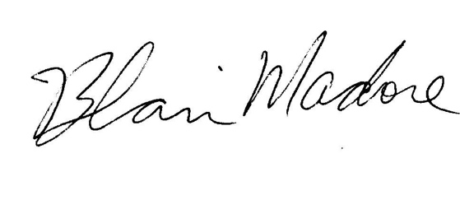

Blair Madore

Associate Professor of Mathematics

Department of Mathematics

State University of New York at Potsdam

44 Pierrepont Av.

Potsdam, NY, USA

13676-2294